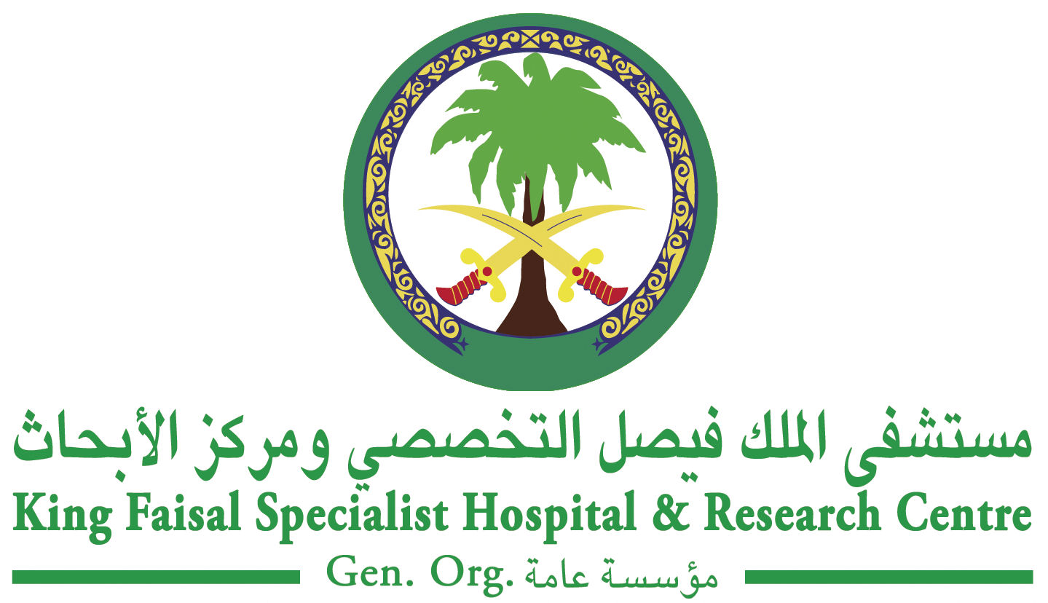

Intensive Course & Workshop:
The World of Medical Physics
King Faisal Specialist Hospital and Research Centre, Riyadh, Kingdom of Saudi Arabia
01 – 03 Muharram 1432 (07 - 09 December 2010)
Training Course and Workshop Fee: SR 1,000
(50% Discount for students and trainees)

REGISTRATION FORM

NOTE: Please print clearly and ensure that you use the correct spelling of your name as you wish it to be printed on the certificate. Use TAB to move between fields.

First  Name: |  |  | Middle Name: |  | Family Name:
Title: | Prof. Dr. Mr. Mrs. Miss Other |  |  |  | Gender: | Male Female
Profession:
Specialty & Qualifications:
Institution Name:
Mailing Address: | City: |  |  |  | Telephone No:
Mailing Address: | Postal Code: |  |  |  | Fax No:
Mailing Address: | Country: |  |  |  | Mobile No:
 |  |  |  |  | Email:
Mode of Payment:

Send completed registration form and payment to:

Ms. Faten Al-Khateeb
Training and Education Office, MBC#03
King Faisal Specialist Hospital & Research Centre
P.O. Box 3354, Riyadh 11211, Kingdom of Saudi Arabia
Tel: +966 (1) 442-3434
Fax: +966 (1) 442-4661
Email: rcteoregistration@kfshrc.edu.sa or FKhateeb@kfshrc.edu.sa
Website: www.radmed.org

Important Information:

- Payment is accepted in cash or certified check made payable to: KFSH&RC Research Centre Grant Fund

- It is mandatory to send the completed registration form so that seating is guaranteed, and payment can be made at the conference site.

- Cancellation/Refund Policy: Request for refund must be received prior to conference start date.

For more information, please visit our website www.radmed.org or contact Ms. Josephine Veridiano, Biomedical Physics Department,
Email: josfin@kfshrc.edu.sa; Tel. No.: +966 (1) 442-7879; Fax: +966 (1) 442-4777


